Experiment : Number is even number of not

a=int(input("Please Enter a Number : "));

if(a%2==0):

print("This Number is Even")

else:

print("This Number is Odd")

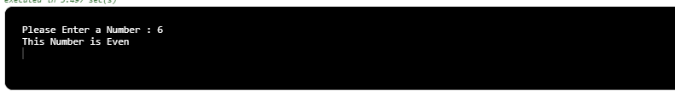

**2.**  find square root of a number

import math

try: #TIP:Always use "try" for "input()" function

a=int(input("Please Enter a Number : "))

print(a)

print(math.sqrt( a ))

except:

print()